# Complete Example (Between Subjects – 1 IV only)

A health psychologist recorded the number of close inter-personal attachments of 45-year-olds who were in excellent, fair, or poor health. People in the Excellent Health group had 4, 3, 2, and 3 close attachments; people in the Fair Health group had 3, 5, and 8 close attachments; and people in the Poor Health group had 3, 1, 0, and 2 close attachments.

**Datafile:** bn 1 anova.csv

**IVs:**

Health group – excellent, fair, poor

**DV:**

Friends - number of close inter-personal attachments

**Power:**

1. Open Gpower!
   1. Test family: F test
   2. Statistical test: ANOVA: fixed one way
   3. Pick an effect size or calculate
   4. Alpha = .05
   5. Power (1-beta .20) = .80
   6. Groups – number of levels.
   7. Hit ok!
2. Says we needed to run 159 people to find a significant effect with a medium effect size.
   1. Pick an effect size or calculate – hit determine 🡪 effect size from variance 🡪 direct, enter eta squared, calculate and transfer to main. Here I left it as a medium effect size.
   2. Alpha = .05
   3. Power (1-beta .20) = .80
   4. Groups 3 for excellent, fair, and poor.

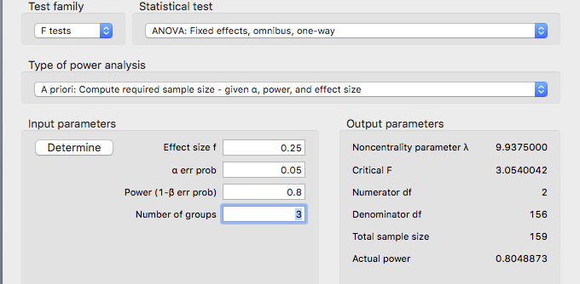

1. Check your learning:
   1. If we have a small effect size (eta square = small, use your notes to find this value), you should get a very large number of estimated participants.
   2. Can you get N = 957?

Example write up:

**Results**

Participants’ numbers of inter-personal connections were examined in relationship to their overall health. The data was screened for assumptions and outliers and found to be satisfactory (Levene’s *F*(2,8) = 1.40, *p* = .30). A between subjects ANOVA was used to analyze the number of inter-personal attachments with excellent, fair, and poor health groups. These group means were found to be significantly different, *F*(2,8) = 5.13, *p* = .04, *η2* = .56. An independent *t*-test with Tukey correction was used to examine differences between groups. As shown in Figure 1, the excellent health group (*M* = 3.00, *SD* = 0.82) was not different from the fair health group (*M* = 5.33, *SD* = 2.52, *t*(5) = -1.95, *p* = .19, *d* = 1.36). The excellent and poor health groups (*M* = 1.50, *SD* = 1.29) were also found to have equal numbers of inter-personal attachments (*t*(6) = 1.35, *p* = .41, *d* = 1.39). However, the fair health group was found to have significantly more attachments than the poor health groups (*t*(5) = 3.20, *p* = .03, *d =* 2.04).

*Figure 1.* Average number of friends by health condition with confidence interval error bars.

**Results**

**Descriptives**

| **Descriptive Statistics** | | | |
| --- | --- | --- | --- |
|  | | **friends** | |
| **Valid** |  | 11 |  |
| **Missing** |  | 0 |  |
| **Mean** |  | 3.091 |  |
| **Std. Deviation** |  | 2.119 |  |
| **Minimum** |  | 0.000 |  |
| **Maximum** |  | 8.000 |  |
|  | | | |

**Plots**

**Distribution Plot**

**friends**

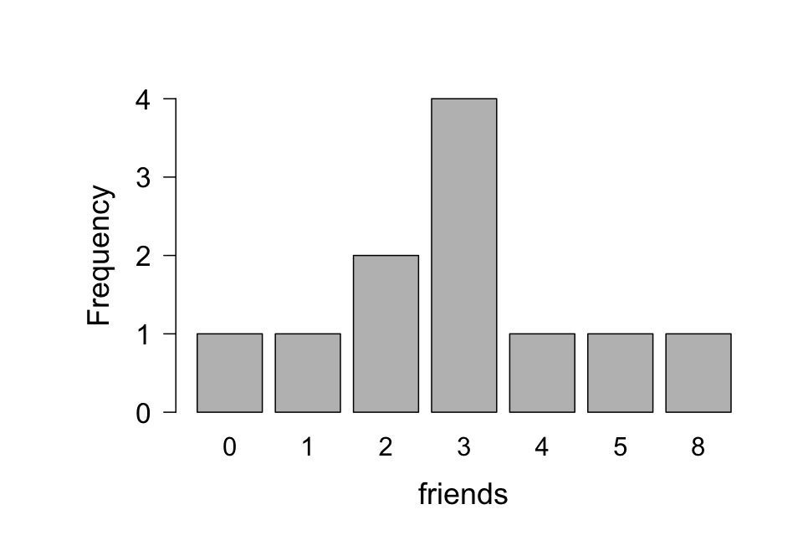

**ANOVA**

| **ANOVA - friends** | | | | | | | | | | | | | |
| --- | --- | --- | --- | --- | --- | --- | --- | --- | --- | --- | --- | --- | --- |
| **Cases** | | **Sum of Squares** | | **df** | | **Mean Square** | | **F** | | **p** | | **η²** | |
| group |  | 25.24 |  | 2 |  | 12.621 |  | 5.134 |  | 0.037 |  | 0.562 |  |
| Residual |  | 19.67 |  | 8 |  | 2.458 |  |  |  |  |  |  |  |
|  | | | | | | | | | | | | | |
| *Note.*  Type III Sum of Squares | | | | | | | | | | | | | |

*F*(2,8) = 5.13, *p* = .04, η² = .56, overall ANOVA is significant (omnibus test)

**Assumption Checks**

| **Test for Equality of Variances (Levene's)** | | | | | | | |
| --- | --- | --- | --- | --- | --- | --- | --- |
| **F** | | **df1** | | **df2** | | **p** | |
| 2.164 |  | 2 |  | 8 |  | 0.177 |  |
|  | | | | | | | |

***F*(2,8) = 2.16, *p* = .18 – non-significant, so homogeneity was met.**

**Q-Q Plot**

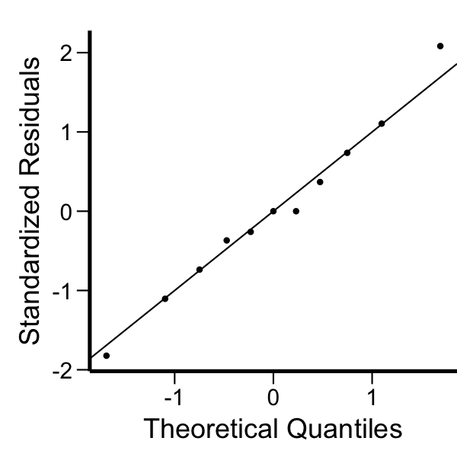

**Post Hoc Tests**

| **Post Hoc Comparisons - group** | | | | | | | | | | | |
| --- | --- | --- | --- | --- | --- | --- | --- | --- | --- | --- | --- |
|  | |  | | **Mean Difference** | | **SE** | | **t** | | **p tukey** | |
| excellent |  | fair |  | -2.333 |  | 1.198 |  | -1.948 |  | 0.187 |  |
|  |  | poor |  | 1.500 |  | 1.109 |  | 1.353 |  | 0.408 |  |
| fair |  | poor |  | 3.833 |  | 1.198 |  | 3.201 |  | 0.030 |  |
|  | | | | | | | | | | | |

NEW NEW NEW

You can now get the effect size directly as part of the post hoc test:



### Post Hoc Tests

| **Post Hoc Comparisons - group** | | | | | | | | | | | | | |
| --- | --- | --- | --- | --- | --- | --- | --- | --- | --- | --- | --- | --- | --- |
|  | |  | | **Mean Difference** | | **SE** | | **t** | | **Cohen's d** | | **p tukey** | |
| excellent |  | fair |  | -2.333 |  | 1.198 |  | -1.948 |  | -0.587 |  | 0.187 |  |
|  |  | poor |  | 1.500 |  | 1.109 |  | 1.353 |  | 0.408 |  | 0.407 |  |
| fair |  | poor |  | 3.833 |  | 1.198 |  | 3.201 |  | 0.965 |  | 0.030 |  |
|  | | | | | | | | | | | | | |
| *Note.*  Cohen's d does not correct for multiple comparisons. | | | | | | | | | | | | | |

Please note that these values use a different denominator than the traditional test that MOTE calculates. Both values would be correct – just different ways of calculating the test.

|  |  |  |  |
| --- | --- | --- | --- |
| Group 1 | Group 2 | Comparison | Effect size |
| Excellent  M = 3.00  SD = 0.82  N = 4 | Fair  M = 5.33  SD = 2.52  N = 3 | *t*(5) = -1.95,  *p* = .19  (not significant) | *d* = -1.36 |
| Excellent  M = 3.00  SD = 0.82  N = 4 | Poor  M = 1.50  SD = 1.29  N = 4 | *t*(6) = 1.35,  *p* = .41  (not significant) | *d* = 1.39 |
| Fair  M = 5.33  SD = 2.52  N = 3 | Poor  M = 1.50  SD = 1.29  N = 4 | *t*(5) = 3.20,  *p* = .03  (significant) | *d* = 2.04 |

**Marginal Means**

| **Marginal Means - group** | | | | | | | | | |
| --- | --- | --- | --- | --- | --- | --- | --- | --- | --- |
| **group** | | **Marginal Mean** | | **SE** | | **Lower CI** | | **Upper CI** | |
| excellent |  | 3.000 |  | 0.784 |  | 1.192 |  | 4.808 |  |
| fair |  | 5.333 |  | 0.905 |  | 3.246 |  | 7.421 |  |
| poor |  | 1.500 |  | 0.784 |  | -0.308 |  | 3.308 |  |
|  | | | | | | | | | |

**Descriptives**

| **Descriptives - friends** | | | | | | | |
| --- | --- | --- | --- | --- | --- | --- | --- |
| **group** | | **Mean** | | **SD** | | **N** | |
| excellent |  | 3.000 |  | 0.816 |  | 4 |  |
| fair |  | 5.333 |  | 2.517 |  | 3 |  |
| poor |  | 1.500 |  | 1.291 |  | 4 |  |
|  | | | | | | | |

**Descriptives Plot**

